API testing

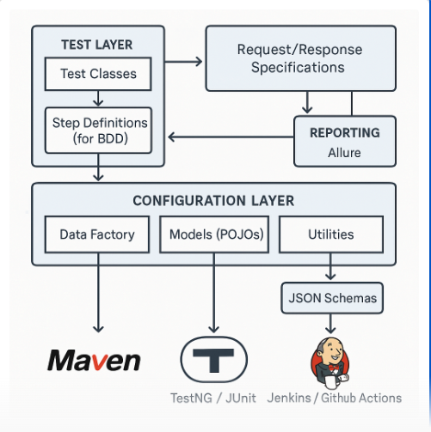

End point: Address where API is hosted on the Server.

HTTP methods which are commonly used to communicate with Rest API’s are

**GET, POST, PUT, and DELETE**

GET- The GET method is used to extract information from the given server using a given URI. While using GET request, it should only extract data and should have no other effect on the data. No Payload/Body required

**How to send input data in GET?**  
Ans: Using Query Parameters

POST- A POST request is used to send data to the server, for example, customer information, file upload, etc. using HTML forms.

**How to send input data in POST?**  
Ans: Using Form Parameters /Body Payload

PUT- Replaces all current representations of the target resource with the uploaded content.

DELETE- Removes all current representations of the target resource given by a URI.

**Resources:  
Resources represent API/Collection which can be accessed from the Server**

Google.com/maps  
google.com/search  
google.com/images

**Path Parameters:**  
**Path parameters** are variable parts of a URL path. They are typically used to point to a specific resource within a collection, such as a user identified by ID

<https://www.google.com/Images/1123343>  
<https://www.google.com/docs/1123343>  
<https://amazon.com/orders/112>

<https://www.google.com/search?q=newyork&oq=newyork&aqs=chrome..69i57j0l7.2501j0j7&sourceid=chrome&ie=UTF-8>

**Query Parameters:**  
Query Parameter is used to sort/filter the resources.

Query Parameters are identified with?””

https://amazon.com/orders?sort_by=2/20/2020

**Headers/Cookies**:

Headers represent the meta-data associated with the API request and response. In layman terms, we were sending Additional details to API to process our request.  
Example : Authorization details

**End Point Request URL can be constructed as below**  
Base URL/resource/(Query/Path)Parameters